Sarve Bhavantu Sukhinah!

May everyone be prosperous and happy!

Dear Investors,
We sincerely hope that you and your dear ones are safe and healthy and we now pray for your prosperity and happiness.
We, the entire humankind, are going through one of the most testing times over the last few months and believe that all of us will emerge from this crisis, healthy, learned and wiser. The events of the last few months have helped us to better appreciate the basic necessities and value relationships in life, which we have always taken for granted. While the crisis is far from over, but the indomitable spirit and survival instinct in us humans has taught us not only to coexist with the virus but also thrive as well. The urgency and the intent to overcome and reclaim our lives and livelihoods can be amply seen in human behaviour all around us. We salute this indomitable human spirit and strongly believe that environment and the economy would bounce back to normalcy over a period of time. We thus believe that the prevailing attractive asset prices, present a decadal opportunity for investors to benefit from!! (seems inconsistent with portfolio strategy line that ‘easy money is off the table’..we may keep one of these)
First of all, talking about Covid and getting it out of the way, barring few countries where covid continues to spread rapidly, in most of the countries we are past the peak, clearly worst is behind, the rate of spread of the disease (R0<1) has come down below 1, i.e. the number of active cases is coming down. Economies are gradually opening up and economic activity is picking up and should normalise over a period of time. What is heartening to note in India is that, while the total number of cases have grown significantly and are increasing rapidly, the growth rate of active cases and death rate have consistently and sharply come down and taken the sting out of the bite. Building of herd immunity and taking precautions while carrying out economic activity is essential till vaccines are developed and mass produced. The focus, now is clearly on getting economic activity back on track along with managing the spread of the disease. One however, needs to keep in mind that market and economic volatility is here to stay for a while and we are not out of the woods yet, as a part of the economy may take couple of quarters to normalise. While economy may witness pain for a large part of current financial year with few businesses forced to operate at lower scale to survive the current environment, the Equity markets have rightly started to look beyond short term pain.
We would now in this newsletter, focus on the unlocking and recovery in the economy and the huge amount of opportunity this presents for the investors and provide an update on portfolio strategy and our investment performance.

Understanding the current policy response by looking at economic crises in the past
Being a student of economic history, again, we would like to wear the lens of history to evaluate the steps taken by policy makers and the consequent recovery process (the time it took for the economic activity to come back to normalcy) during the Great Depression of 1929 and the Great Financial Crisis of 2008. This would help us to better understand how the recovery process is likely to pan out and the lessons that we draw can help us make sound investment decisions.
Kapil Gupta of Edelweiss explains in “Blindspot: of deflation, devaluation and asset classes”, that there are essentially two ways to tackle an economic crisis: the choice is essentially between Deflation and Devaluation. Deflation is about fall in credit, wages and prices leading to classical adjustment of imbalances while, Devaluation is about printing money, depreciating the currency and inflating out of the problem.
The Great Depression: The policy response was weakest; policy makers followed sound money approach and believed that the economic excesses should adjust themselves. Thus credit, wages and prices fell, there was a lot of economic pain and it took 11 years and world war spending for the economy to reach its previous peak.
The Great Financial Crisis: The policy response from G7 countries was very aggressive; there was significant expansion of central bank balance sheets, a lot of money was printed and pumped into the financial system. This led to decline in currencies and rise in inflation and economic activity was restored to pre-crisis levels in a few years’ time with much less economic pain.
The policy response in the current crisis has been unprecedented, far more aggressive in scale and scope and the amount of money printed has been massive and far outstrips that during the financial crisis. We thus believe that the unimaginable amount of liquidity created would find its way across markets and economies, devalue currencies, increase inflation and restore economic activity to pre-covid levels much sooner.
Another interesting aspect this time, different from the GFC, has been that the money has been transferred directly to the households and pushed as credit to businesses rather than going into the financial markets. This is already leading to unprecedented growth in money supply, personal income and savings rate and rise in private sector and govt. credit. We believe that this over time should propel money multiplier and higher nominal GDP growth for the world. Thus, global growth recovery should be much faster and sharper and drive export oriented companies, global cyclicals, commodities and Emerging Market assets rather than defensives that worked well over the last decade.
Indian policy response however, has been far more measured and calculated as compared to the GFC. While, a lot of liquidity has been created in the financial system, fiscal response has been cautious and thus, demand recovery, prices, wages and credit growth revival would be gradual. At the same time, rural economy seems to be in far better shape with good monsoons over the last 2 years, much favourable agri terms of trade and huge amount of fiscal spending in the rural areas.
We also believe that another powerful trend unfolding in India can be a big growth driver for the Indian economy over the next few years.

Domestic manufacturing: Participation in global supply chain and import substitution
India’s GDP growth rate has skirted 7.5-8% a number of times since 2003, however, it has struggled to consistently maintain that range. One of the main reasons cited by the economists has been the abysmally low contribution and growth of manufacturing in the GDP given that we are a developing country. Manufacturing is 15-17% of our GDP vs say China where it is about 39-40%. In other emerging economies in Asia like Thailand and Malaysia also manufacturing has been in the range of 37% to 39% of GDP. Manufacturing has been key driver in the journey of other nations like Japan, South Korea, in their transformation from developing to a developed country. Low growth and contribution of manufacturing has not only impacted GDP growth, it has also had a negative effect on India’s infamous twin deficits namely fiscal and trade deficit.
Many believe that the bus has already been missed as most of the supply chains are now well established. It is rare that one gets a second chance, however, prevailing geo-political and economic environment may just be doing that. Events like US-China trade war and Covid-19 have clearly exposed the vulnerabilities in the global supply chain and risks of over concentration and over-dependence on China (contributing to 13% of global exports). India (m/s in global exports of only 1.7%) may benefit as global companies make effort towards diversification of their supply chains. Over last few years, China has lost part of its cost competitiveness due to rising labour costs and stricter environment health and safety regulations. This has already helped companies in certain sectors like Chemicals to compete more effectively with larger Chinese companies. Another important evolving trend is the move towards self-reliance and import substitution which can potentially drive huge shift in domestic manufacturing. We believe, that India is singularly the best suited to capitalise on these trends. There is a lot of awareness, sensitivity and effort going on in the direction. However, the same would not be a cakewalk and a lot more needs to be done.
In this era of globalization, where supply chains are complex and mostly driven by economics and profit motive, global cost competitiveness is paramount. Various estimates presented by industry and companies suggest that manufacturing costs in India are higher by around 12-15% viz-a-viz China and other South East Asian countries. India presents a large domestic market opportunity, which to some extent can mitigate the higher cost of operations in India.
Higher costs of operating in India are due to a number of factors a) High cost of capital; b) Higher Taxation; c) Land- Expensive and difficult to get; d) Labour- low productivity; e) High cost of power; d) Poor infrastructure leading to higher logistics costs; and finally e) Policy uncertainty and difficulty of doing business in India. Also, domestic manufacturing suffers due to low scale of operations and lesser access to technology as a result of generally low R&D spend in the country.
Government is laying emphasis on reviving manufacturing in the country through various measures. Some of the steps being undertaken that are likely to support domestic manufacturing include a) Improved Infrastructure (Road, Ports and upcoming Rail freight corridors); b) Production linked incentive schemes; c) Availability of capital by allowing higher FDI in certain sectors and d) Protection to domestic manufacturing by increasing import duties, e) Creation of land bank to be provided for setting up industries. It is also being proposed to introduce non-tariff barriers such as minimum standards for products to discourage import of poor quality goods in the country. Work is also being done to provide power at competitive rate to industry through various reforms in the sector and serious attempts are being made at state level to tackle the politically difficult subject of reform in labour laws.
One important factor in developing competitiveness is the development of entire ecosystem for a particular Industry i.e. local manufacturing of parts and availability of skilled labour. This, over a period of time, with absorption of current level of technology, helps develop new products (Innovation). In India, Automobile - Small Cars and Two Wheelers are perfect example of global cost competitiveness and development of a very large and efficient ecosystem. We need to replicate this in other sectors as well.
We have many sectors with high dependency on imports either for intermediate stage of manufacturing like Pharmaceuticals and Chemicals or for the entire value chain such as in Electronics, Solar Energy, Telecom Equipment. Also, some businesses such as Capital goods and Steel have been suffering from price pressure even when local production base is present.

With all the steps being undertaken and recent developments in global trade and politics, we are hopeful that Indian manufacturing sector will get a strong boost and grow at higher than our country GDP growth rate. Shift in GDP composition by 5% in favour of manufacturing over a 5-6 year period will present a minimum USD 150-200 bn opportunity for companies beyond the usual growth in the segment. Local manufacturing and investment opportunity can be broadly segmented into two parts
- Indigenization of supply chains- Where local or foreign companies make intermediate products or raw materials in India. Sectors where we expect activity on this front is Pharmaceutical APIs, Chemicals, Electronics, Electrical equipment including consumer durables and Solar Energy.
- Export hub- With global supply chain looking for diversification, some companies may also move their production to India, attracted by large domestic market (enabling scale in operations thereby reducing per unit cost) and benefits offered by government. Following sectors may witness higher growth rates in exports - Auto and Auto Components, Capital Goods, Textile, Steel, Electronics-Mobile phones

This investment and growth of manufacturing drives increase in value addition, , brings down unemployment, leads to skill development, pulling people above the poverty line in the country, boosts demand leading to all round sustainable growth in the economy. Benefits of which can be felt across sectors, especially capital goods and construction, evolution over a period of time of large logistics chains etc.
We expect some of these sectors to present large investment opportunities over a period of time to capitalise on.

Equity Markets and Portfolio Strategy:
The last 2 quarters have been among the most volatile periods in the history of Indian equity markets. In the environment, when economies were closed but the markets were open, we witnessed a mad rush to liquidate assets, create and hoard cash. This drove the worst market behaviour globally with markets falling vertically by more than 35% on average, in a short span of time and accompanied with unprecedented volatility. Excessive pessimism and very low affinity for risk led to market valuations correcting significantly to decadal lows. Many large, big, well known and high quality companies and businesses were available at prices last seen 10 years back. The valuations and volatility Index (VIX) showed that most of the negatives got more than discounted.
This was followed by gradual opening up of the economy and economic activity since has gradually started picking up. Various indicators of economic activity like fuel demand, auto sales, railway freight, e-way bills, GST collection, manufacturing PMIs indicate that economic activity is on gradual uptick, has reached 60-65% of the pre-covid levels and improving m-o-m. This has led to swift bounce-back in the equity markets as well, moving up ~35% from the bottom with trailing valuation indicators of large cap indices now close to the long term average levels. However, midcap and smallcap segment has underperformed largecaps by 30% and 49% respectively since Dec’17, and continues to offer lot of value.
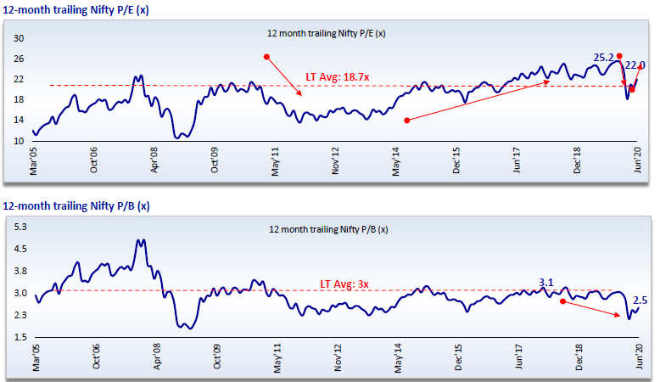
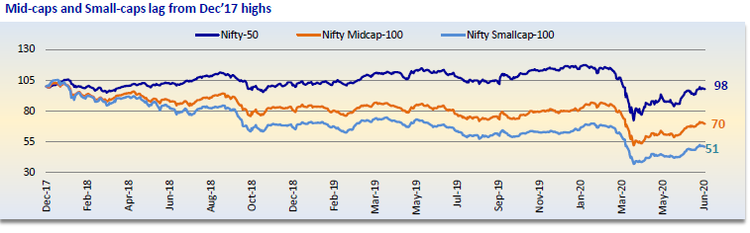
Source: Motilal Oswal securities

Given the above, we think that easy money in the equity markets is now off the table and going forward it would be a slow and gradual grind up as the economic data improves. Going forward it would be more of bottom up stock picking which would deliver superior returns. There are pockets available in the large cap space along with the midcap and smallcap segment that still continue to remain very attractive and provide value hunting opportunities. Hence it is recommended to increase equity allocation and invest in good companies slowly on every decline keeping in mind that recovery will be gradual and there will be mean reversion in the long term.

Investment Performance:
In the end we want to share the investment performance of your funds. In the last quarter we shifted our focus to large cap companies as the valuation gap between large caps and mid-caps had narrowed down significantly and this made eminent sense from risk-reward perspective. The same has benefitted your funds immensely.
We are extremely happy and proud to report that given our investment approach of focus on high quality companies with high margin of safety, the maximum drawdown that your funds in Green Lantern Capital Alpha Fund witnessed was 19% (mkt down 35%), outperforming the market by a wide margin.

It was also very heartening to see that during market recovery also, your funds more than recovered the worst draw down and moved up sharply and came in profit even though the market remains in negative territory.

Index | 13/02/2020 | 30/06/2020 | Performance
Nifty 50 | 12175 | 10302 | -18.2%
BSE 500 | 15891 | 13438 | -18.3%
GLC Alpha |  |  | 5.1%

